**Data Flow Diagram:**

Project Design Phase-II

Data Flow Diagram & User Stories

|  |  |
| --- | --- |
| Date | 13 October 2022 |
| Team ID | PNT2022TMID28152 |
| Project Name | Project – Car Resale Value Prediction |
| Maximum Marks | 4 Marks |

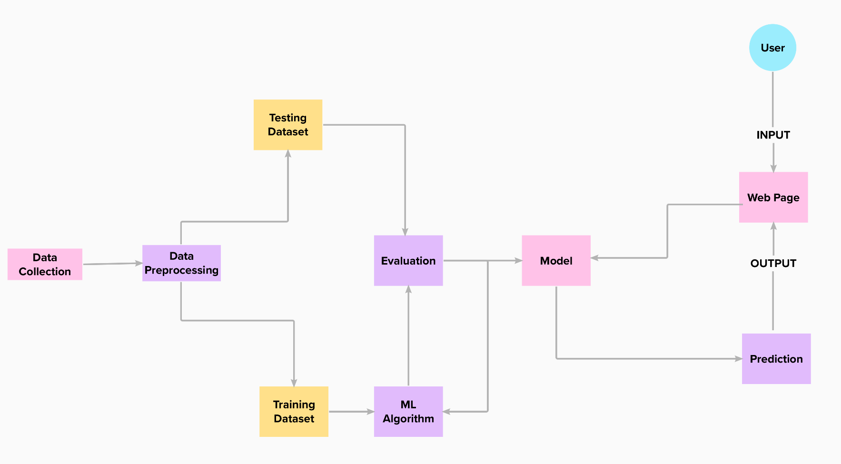

**User Stories**

Use the below template to list all the user stories for the product.

|  |  |  |  |  |  |  |
| --- | --- | --- | --- | --- | --- | --- |
| **User Type** | **Functional**  **Requirement (Epic)** | **User Story Number** | **User Story / Task** | **Acceptance criteria** | **Priority** | **Release** |
| Customer (Mobile user) | Data Entry | USN-1 | As a user, I can enter the car details in the application. | I can enter the car details | Medium | Sprint-1 |
| Customer (Mobile user) | Obtain output | USN-2 | As a user, I will receive car resale value in the application. | I can receive my carresale value | High | Sprint-1 |
| Customer (Mobile user) | Data Entry | USN-1 | As a user, I can enter the car details in the application. | I can enter the car details | Medium | Sprint-1 |
| Customer (Mobile user) | Obtain output | USN-2 | As a user, I will receive car resale value in the application. | I can receive my carresale value | High | Sprint-1 |